**Team 8**

**Undergraduate Project**

**Software Verification & Validation Plan (SVVP)**

**Authors: Brett Malmquist & Joe Cullinan**

**Group Members: Ben Miloshoff, Arjun Agrawal, Joe Cullinan,**

**Geonhyuk Im, Brett Malmquist, Ekenechukwu Nwannunu, Adam**

**Richard, Christian Schubert**

**Date: (04/19/2021)**

# Table Of Contents

**Table Of Contents** **2**

**1. Purpose** **3**

**2. References** **3**

**3. Definitions** **3**

**4. Verification & Validation Overview** **4**

**5. Organization** **4**

**6. Master Schedule** **4**

**7. Software Integrity Level Scheme** **7**

**8. Responsibilities** **7**

**9. Tools, Techniques, & Methods** **8**

# 1. Purpose

The Software Verification and Validation Plan (SVVP) is necessary in evaluating the software we have developed to ensure it meets the exact requirements of the user. It defines the rigorous testing throughout the development of the product to ensure it meets the standards of the team and works fluently and bug-free.The systematic monitoring of Team 8’s software and processes will be evaluated to ensure they comply with the requirements of the professor and/or user and comply with the Institute of Electrical and Electronic Engineers (IEEE) standards.

# 2. References

* IEEE Software Verification and Validation Plane - IEEE Std 1012-1998
* Braude, E. J., & Bernstein, M. E. (2016). *Software engineering: Modern approaches*. Long Grove: Waveland Press.

# 3. Definitions

|  |  |
| --- | --- |
| **TERM/ACRONYM** | **DEFINITION** |
| IEEE | Institute of Electrical and Electronic Engineers |
| SQAP | Software Quality Assurance Plan |
| SVVP | Software Verification & Validation Plan |
| PM | Project Manager |
| SA | Software Architect |
| IE | Integration Engineer |
| RE | Requirements Engineer |
| TE | Testing Engineer |

# 4. Verification & Validation Overview

Just as described in section 1 of the purpose, we are designing and engineering a data visualization system used for analyzing data and being able to visualize several different diagrams. Through verification and validation we are able to monitor the team’s efforts and review all the source code that has been provided in order to ensure a quality product.

# 5. Organization

Our team is made up of eight undergraduate students with five separate roles so some roles are used more than once depending on what areas we deemed needed more attention. These roles include Project Manager (PM), Requirement Engineer (RE), Software Architect (SA), Integration Engineer (IE), Testing Engineer (TE), and Code Developer (CD).

The students roles are as followed:

* Arjun Agrawal - Project Manager
* Ekenechukwu Nwannunu - Requirement Engineer
* Adam Richard - Requirement Engineer
* Ben Miloshoff - Software Architect
* Christian Schubert & Geonhyuk Im - Integration Engineer
* Brett Malmquist & Joe Cullinan - Testing Engineer

In accordance with the software verification and validation plan, it is the responsibility of the testing engineers to certify all the work put in by the team is meeting the criteria set out by the user and ensure quality in a consistent and efficient manner.

# 6. Master Schedule

As the project ensued, there were various issues that the team ran into and those issues were solved in a timely manner using this model.

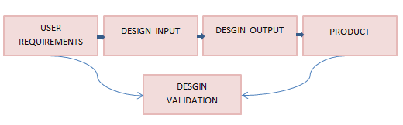

|  |  |  |  |
| --- | --- | --- | --- |
| **Version** | **Change Date** | **By** | **Description** |
| version number | Date of Change | Name of person who made changes | Description of the changes made |
| 0.0 | 2/4/2021 | Unanimous | Layout of Design & Requirements |
| 0.1 | 2/27/2021 | Joe Cullinan & Arjun Agrawal | Main Page updated and links to each of other pages |
| 0.2 | 3/8/21 | Ben Miloshoff | Implement Webex Into Mainpage |
| 0.3 | 3/14/21 | Ben Miloshoff & Adam Richard | Main Menu Page Updated |
| 0.4 | 3/22/21 | Brett Malmquist & Adam Richard | Histogram worked on |
| 0.5 | 3/25/21 | Ben Miloshoff | BarChart worked on |
| 0.6 | 3/28/21 | Geonhyuk Im, Ekenechukwu Nwannunu, and Christian Schubert | BoxPlot worked on |
| 0.7 | 3/30/21 | Geonhyuk Im, Ekenechukwu Nwannunu, and Christian Schubert | GroupBoxPlot worked on |
| 0.8 | 3/31/21 | Arjun Agrawal & Joe Cullinan | ScatterPlot worked on |
| 0.9 | 4/4/21 | Arjun Agrawal & Joe Cullinan | StackedBarChart worked on |
| 1.0 | 4/13/21 | Arjun Agrawal, Joe Cullinan, Ben Miloshoff, Brett Malmquist, & Adam Richard | Fixed issue with StackedBarChart not working |
| 1.1 | 4/17/21 | Brett Malmquist and Joe Cullinan | Testing and debugging done |

# 7. Software Integrity Level Scheme

The team decided as a whole to use the model of iterative and incremental development.

We did not want to start designing everything on the webpage at once without the validation that everything is working as it should before moving onto the next piece.

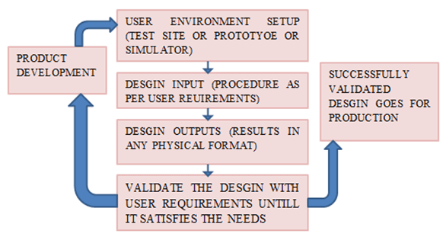

Each step of the webpage followed this chart before we verified and validated that everything was working in union with each other.

# 8. Responsibilities

* **Project Manager**: The PM is responsible for keeping the team on track and oversees every single team member to make sure everyone is playing their part. The PM is also responsible for assessing each team member to make sure they are understanding and timing their goals in a consistent and timely manner.
* **Requirement Engineer**: The RE’s responsibilities are to communicate the User/Product Director’s requirements to the team. The role is required to translate the requirements set by the User and translate that to the team as functional requirements. This is necessary for the team to be able to meet the criteria set by the user.
* **Software Architect**: The SA is responsible for translating the functional requirements set by the RE into high level design specifications. As the development continues, the SA is required to meet with the RE in order to make sure that the criteria set out by the user is met within the prototype.
* **Integration Engineer**: The IE is responsible for module interfaces and integration. This includes the transfer of data between modules and producing the integrated source code. They report with the code developers and requirement engineer to carry out the prototype demonstration in accordance with the criteria standards set by the RE.
* **Testing Engineer**: The TE is responsible for the product’s functional testing and quality assurance. They are to overlook all the source code to make sure there are no bugs in the code, testing the system to make sure it works adequately and to the RE’s standards, and accepting the product before it is prototyped.

As each responsibility is fulfilled by each member of the team. The verification and validation is also fulfilled by the testing engineers. After each design implementation was made to the product, the testing engineers verified and validated that each piece of the web design was working to it’s requirements and satisfied the criteria set out by the RE.

# 9. Tools, Techniques, & Methods

* Visual Studio Code serves as the IDE tool for the web application
* Plotly is used for the data visualization models within the application
* BeluahWorks, LLC provided the wireframe for the web application